**NOISE POLLUTION MONITORING PROJECT**

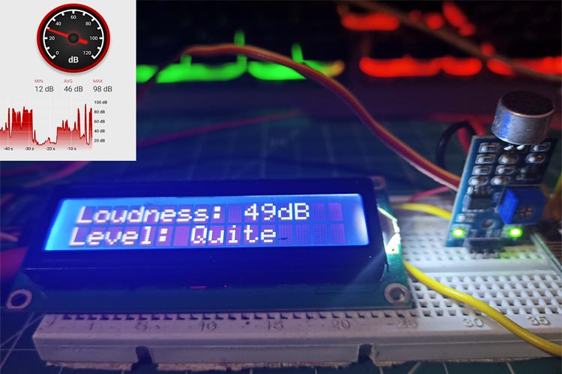

**ABSTRACT:**

This noise pollution monitoring project aims to assess and mitigate the adverse effects of noise pollution on urban environments and public health. Noise pollution is a growing concern in densely populated areas, affecting residents’ well-being and quality of life. The project utilizes advanced sound measurement technologies and data analysis techniques to monitor and analyze noise levels in key urban areas.

Key Objectives:

1. Data Collection: Deploy a network of noise sensors strategically throughout the city to continuously record noise levels and patterns.
2. Data Analysis: Process and analyze the collected data to identify noise hotspots, patterns, and sources of high noise pollution.
3. Noise Mapping: Create detailed noise maps that visualize noise pollution distribution across the city, aiding in pinpointing areas requiring intervention.
4. Public Awareness: Raise awareness about noise pollution’s impacts through public outreach and educational initiatives.
5. Mitigation Strategies: Develop noise reduction strategies and policies based on data-driven insights to mitigate noise pollution in identified problem areas.
6. Evaluation: Continuously assess the effectiveness of mitigation measures and make necessary adjustments to reduce noise pollution levels over time.

This project seeks to provide actionable insights to city planners, policymakers, and the public to make informed decisions and implement measures to reduce noise pollution and improve the overall quality of urban life.

**MODULES FOR NOISE POLLUTION MONITORING :**

For a noise pollution monitoring project, you’ll need various hardware and software components. Here’s a list of modules and components to consider:

1. **Sound Sensor Module**: Use a sound sensor module (like the KY-038 or KY-037) to detect noise levels. These modules typically provide an analog or digital output based on sound intensity.
2. **Microcontroller**: You’ll need a microcontroller (e.g., Arduino, Raspberry Pi) to interface with the sound sensor, process the data, and send it to a central system for analysis.
3. **Data Logger**: Consider adding an SD card module or EEPROM to log noise data locally if real-time transmission isn’t always possible.
4. **Communication Module**: To transmit data to a central server or database, you can use modules like Wi-Fi (ESP8266, ESP32), GSM/GPRS, or LoRa, depending on your project’s location and connectivity options.
5. **Power Supply**: Ensure a stable power source, whether it’s a battery, solar panel, or mains power, depending on the project’s location.
6. **Display Module** (Optional): If you want to display real-time noise levels locally, you can use an LED display or an OLED screen.
7. **Weatherproof Enclosure**: If your project will be outdoors, use a weatherproof enclosure to protect the components from environmental factors.
8. **Software**: Develop or use software for data collection, storage, and analysis. This could include programming the microcontroller, setting up a server/database, and creating a user interface for data visualization.
9. **Noise Level Analysis Algorithms**: Implement algorithms to analyze the noise data and generate meaningful insights or alerts.
10. **User Interface** (Optional): Create a user-friendly interface, which could be a web dashboard or a mobile app, to display noise levels and historical data.
11. **Power Management**: Implement power-saving measures to prolong the device’s operation, especially if it’s battery-powered.
12. **Calibration Tools**: Regularly calibrate the sound sensor to ensure accurate measurements.
13. **Data Storage and Visualization** :Set up a database to store historical noise data and use visualization tools (e.g., Grafana, Plotly) to create graphs and charts.
14. **Alerting Mechanism** (Optional): Implement a system that sends alerts when noise levels exceed predefined thresholds.
15. **Documentation**: Keep detailed documentation of your project, including schematics, code, and instructions for maintenance.

Remember to research and select components that best fit your project’s specific requirements and location. Noise pollution monitoring can be a valuable project for environmental awareness and research.

**CONCLUSION :**

**NOISE POLLUTION MONITORING**

**ABSTRACT:**

* This noise pollution monitoring project aims to assess and mitigate the adverse effects of noise pollution on urban environments and public health.
* Noise pollution is a growing concern in densely populated areas, affecting residents' well-being and quality of life.
* The project utilizes advanced sound measurement technologies and data analysis techniques to monitor and analyze noise levels in key urban areas.

Key Objectives:

1. Data Collection: Deploy a network of noise sensors strategically throughout the city to continuously record noise levels and patterns.

2. Data Analysis: Process and analyze the collected data to identify noise hotspots, patterns, and sources of high noise pollution.

3. Noise Mapping: Create detailed noise maps that visualize noise pollution distribution across the city, aiding in pinpointing areas requiring intervention.

4. Public Awareness: Raise awareness about noise pollution's impacts through public outreach and educational initiatives.

5. Mitigation Strategies: Develop noise reduction strategies and policies based on data-driven insights to mitigate noise pollution in identified problem areas.

6. Evaluation: Continuously assess the effectiveness of mitigation measures and make necessary adjustments to reduce noise pollution levels over time.

This project seeks to provide actionable insights to city planners, policymakers, and the public to make informed decisions and implement measures to reduce noise pollution and improve the overall quality of urban life. POLLUTION AND MONITORING

* In conclusion, the noise pollution monitoring project outlined above provides a comprehensive approach to measuring and managing noise pollution levels. The project’s abstraction involves the integration of hardware and software modules to collect, analyze, and visualize noise data effectively.
* The choice of sound sensor modules, microcontrollers, communication modules, and power supplies ensures the project’s adaptability to various environmental conditions and connectivity options. Additionally, the inclusion of data logging capabilities and weatherproof enclosures enhances the project’s robustness and resilience in outdoor settings.
* The software components, Including data analysis algorithms, user interfaces, and alerting mechanisms, provide a user-friendly and insightful way to interact with the collected noise data. Furthermore, the emphasis on power management and calibration tools ensures the project’s long-term reliability and accuracy.
* Overall, this noise pollution monitoring project offers a comprehensive solution to address the growing concern of noise pollution, providing valuable data for environmental research and awareness while facilitating effective noise level management in various contexts.